1. Download the course .imscc file here (this link or set of instructions would be replaced with the actual method for users to download the .imscc file specific to them).
2. Access your Canvas course and in the Course Navigation, click the Settings link.
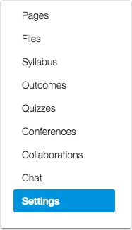

3. Click the Import Content into this Course button.
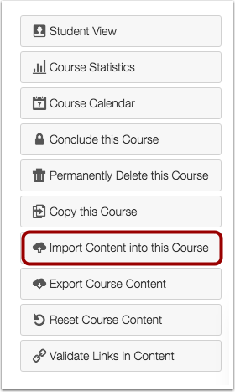

4. In the Content Type drop-down menu, choose the Canvas Course Export Package option.
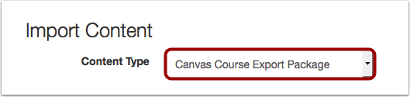

5. Click the Choose File button.
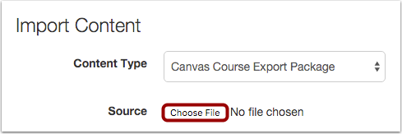

6. Locate and select the .imscc file that was previously downloaded, then click the Open button.
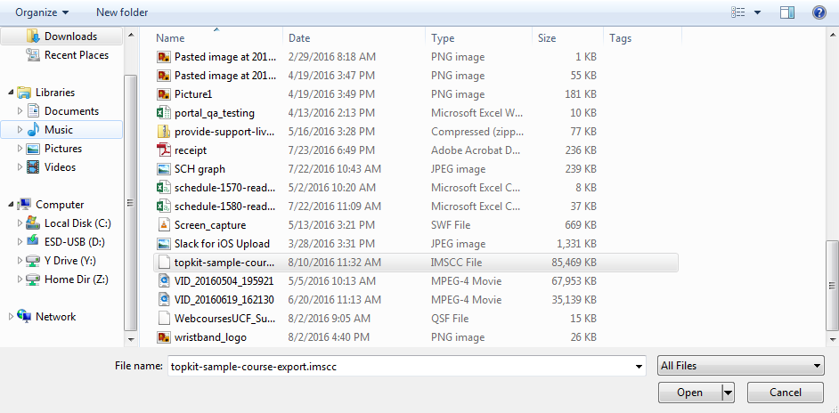

7. To import all content from the course, select the All Content radio button. If you want to select specific content, slick the Select specific content radio button.
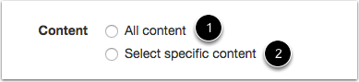
Note: If you select the specific content option, you are required to select the content you want to import; otherwise, all content will be imported directly into your course.

8. Click the Import button.
